Gadtardi Pratama Wongkaren 2301929480

PART 1

1. What does Python print as a result of this statement:

**print(7 + 23)**

(a) 7 + 23

(b) 7 + 23 = 30

**(c) 30**

(d) This produces an error.

2. Which of the following are valid variable names?

**(a) _1_2_3_**

(b) ms.NET

**(c) WoW**

(d) green-day

(e) big!fish

**(f) 500_days_of_summer**

3. Which of the following are valid identifiers?

**(a) a1b2c**

**(b) 1a2b3**

**(c) a_b_c**

**(d) _a_b_**

(e) a-b-c

(f) -a-b-

**(g) aBcDe**

(h) a.b.c

4. Suppose the variable x has the value 5 and y has the value 10. After executing these statements:

**x = y**

**y = x**

what will the values of x and y be, respectively?

(a) 5 and 10

(b) 10 and 5

**(c) 10 and 10**

(d) 5 and 5

5. **True** or False: “x ** 2” yields the identical result that is produced by “x * x” for all

integer and float values of x.

6. True or **False**: “x ** 2.0” yields the identical result that is produced by “x * x” for all

integer and float values of x.

7. What does Python print as a result of this statement?

**print(5 + 6 % 7)**

(a) This produces an error.

(b) 5 + 6 % 7

**(c) 11**

(d) 4

8. What is the output from the print() statement in the following code?

**x = 3 % 4 + 1**

**y = 4 % 3 + 1**

**x, y = x, y**

**print(x, y)**

(a) 2 4

**(b) 4 2**

(c) 0 3

(d) 3 0

9. What is the output produced by the following code?

**x = 3**

**y = 4**

**print("x", "y", x + y)**

(a) 3 4 7

**(b) x y 7**

(c) x y x + y

(d) 3 4 x + y

(e) x y 34

For each of the following, determine the value to which the expression evaluates. (Your answer

should distinguish between floats and ints by either the inclusion or exclusion of a decimal

point.)

10. 5.5 - 11 / 2

**0.0**

11. 5.5 - 11 // 2

**0.5**

12. 10 % 7

**3**

13. 7 % 10

**7**

14. 3 + 2 * 2

**7**

15. 16 / 4 / 2

**2.0**

16. 16 / 4 * 2

**8.0**

17. Given that the following Python statements are executed:

**a = 2**

**b = a + 1 // 2**

**c = a + 1.0 // 2**

**d = (a + 1) // 2**

**e = (a + 1.0) // 2**

**f = a + 1 / 2**

**g = (a + 1) / 2**

Determine the values to which the variables b through g are set.

**b=2**

**c=2.0**

**d=1**

**e=1.0**

**f=2.5**

**g=1.5**

18. What output is produced when the following code is executed?

**hello = "yo"**

**world = "dude"**

**print(hello, world)**

(a) hello, world

**(b) yo dude**

(c) "yo" "dude"

(d) yodude

(e) This produces an error.

19. The following code is executed. What is the output from the print() statement?

**x = 15**

**y = x**

**x = 20**

**print(y)**

**(a) 15**

(b) 20

(c) y

(d) x

(e) This produces an error.

20. The following code is executed. What is the output from the print() statement?

**result = "10" / 2**

**print(result)**

(a) 5

(b) 5.0

(c) ’"10" / 2’

**(d) This produces an error.**

21. The following code is executed. What is the output from the print() statement?

**x = 10**

**y = 20**

**a, b = x + 1, y + 2**

**print(a, b)**

(a) 10 20

**(b) 11 22**

(c) ’a, b’

(d) ’x + 1, y + 2’

(e) This produces an error.

22. True or **False**: In general, “x / y * z” is equal to “x / (y * z)”.

23. **True** or False: In general, “x / y ** z” is equal to “x / (y ** z)”.

24. True or **False**: In general, “w + x * y + z” is equal to “(w + x) * (y + z)”.

25. **True** or False: In general, “w % x + y % z” is equal to “(w % x) + (y % z)”.

26. True or **False**: If both m and n are ints, then “m / n” and “m // n” both evaluate to

ints.

27. True or **False**: The following three statements are all equivalent:

**x = (3 +**

**4)**

**x = 3 + \**

**4**

**x = """3 +**

**4"""**

28. Given that the following Python statements are executed:

**x = 3 % 4**

**y = 4 % 3**

What are the values of x and y?

**x=1**

**y=1**

29. To what value is the variable z set by the following code?

**z = 13 + 13 // 10**

(a) 14.3

(b) 14.0

(c) 2

**(d) 14**

(e) 16

30. Assume the float variable ss represents a time in terms of seconds. What is an appropriate

statement to calculate the number of complete minutes in this time (and store the result as an

int in the variable mm)?

**(a) mm = ss // 60**

(b) mm = ss / 60

(c) mm = ss % 60

(d) mm = ss * 60

31. To what values does the following statement set the variables x and y?

**x, y = divmod(13, 7)**

(a) 6 and 1

**(b) 1 and 6**

(c) 6.0 and 2.0

(d) This produces an error.

Part 2

1. Write a small program that assigns an angle in degrees to a variable called degrees. The program converts this angle to radians and assigns it to a variable called radians. To convert from degrees to radians, use the formula radians = degrees _ 3:14=180 (where we are using 3:14 to approximate pi). Print the angle in both degrees and radians.

The following demonstrates the program output when the angle is 150 degrees:

Degrees: 150

Radians: 2.616666666666667

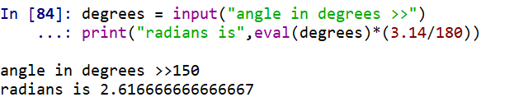

2. Write a program that calculates the average score on an exam. Assume we have a small class of only three students. Assign each student’s score to variables called student1, student2, and student3 and then use these variables to find the average score. Assign the average to a variable called average. Print the student scores and the average score.

The following demonstrates the program output when the students have been assigned scores

of 80.0, 90.0, and 66.5:

Student scores:

80.0

90.0

66.5

Average: 78.83333333333333

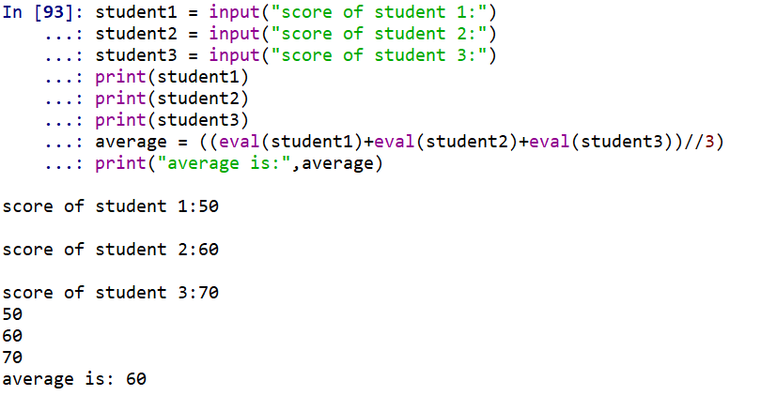

3. Imagine that you teach three classes. These classes have 32, 45, and 51 students. You want to divide the students in these classes into groups with the same number of students in each group, but you recognize that there may be some “left over” students. Assume that you would like there to be 5 groups in the first class (of 32 students), 7 groups in the second class (of 45 students), and 6 groups in the third class (of 51 students). Write a program to calculate the number of students in each group (where each group has the same number of students). Print this number for each class and also print the number of students that will be “leftover” (i.e., the number of students short of a full group). Use simultaneous assignment to assign the number in each group and the “leftover” to variables.

The following demonstrates the program’s output:

Number of students in each group:

Class 1: 6

Class 2: 6

Class 3: 8

Number of students leftover:

Class 1: 2

Class 2: 3

Class 3: 3

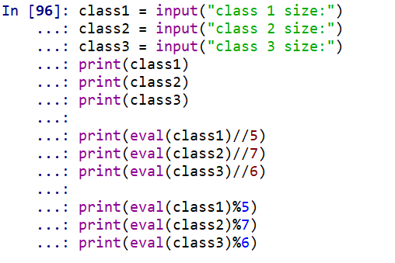

4. The Python statements below have several errors. Identify the errors and correct them so that the program properly calculates the circumference of Jimmy’s pie (circumference = 2*pi*r).

pi = ’3.14’

**pi=3.14**

pie.diameter = 55.4

**piediameter=55.4**

pie_radius = pie.diameter // 2

**pie_radius = piediameter /2**

circumference = 2 * pi ** pie_radius

**circumference = 2*pi*pie_radius**

circumference-msg = ’Jimmy’s pie has a circumference: ’

**circumference_msg = “jimmy’s pie has a circumference:”**

print(circumference-msg, circumference)

**print(circumference_msg, circumference)**

The following demonstrates the output from the corrected program:

Jimmy’s pie has a circumference: 173.956

5. Write a program that calculates the wavelength of a wave traveling at a constant velocity given the speed and the frequency. Use the formula lambda = v/f, where lambda is wavelength in meters, v is velocity in meters per second, and f is frequency in Hertz (cycles per second). Print the velocity, frequency, and wavelength. Assign each of these values to a variable and use the variables in your print() statements.

The following demonstrates what the program prints:

The speed (m/s): 343

The frequency (Hz): 256

The wavelength (m): 1.33984375

{End of Exercise}

